# ANALYSING HOUSING PRICES IN METROPOLITAN AREAS OF INDIA

1. **INTRODUCTION**
   1. **Overview**

The Indian real estate market is one of the fastest-growing sectors of the economy and is a key driver of economic growth in the country. The market has been growing rapidly over the past few years, driven by factors such as increasing urbanization, rising incomes, and a growing middle class. Various Reports suggest that the property market in India will exhibit a compound Annual growth rate of 9.2% during the period between 2023 and 2028. According to Industry veterans, 2023 will be a momentous year for the industry. In 2021 the size of the Indian property market was USD 200 billion. Projected growth by 2030 for the sector is USD 1 trillion. What is more, by 2025, the real estate sector is expected to contribute 13% of the country’s total GDP.

The real estate market is diverse and comprises of various segments such as residential, commercial, retail and industrial properties. The real estate sectors in India have witnessed significant regulatory reforms in recent years, including the introduction of the Real Estate (Regulation and Development) Act, 2016 (RERA) and the Goods and Services Tax (GST). These reforms have helped to bring transparency and accountability to the sector and have improved consumer confidence.

* 1. **Purpose**

The Block takes you through the current Real Estate trends in the Indian Market.

* Continued Demand for larger homes
* High demand for affordable housing
* Rise of demand for homes in urban areas
* Greater adoption of technology
* Emergence of co-living spaces
* Work from Home

The Year 2022 saw the demand for houses in India increase by 34% to reach a nine-year-high in a trend driven primarily by a post-pandemic need for security, Increased savings and relatively little income disruption for middle-and higher-Income groups.

In this project we can make a comparison of the property with others in the same area aspects such as size, price and other elements will help you determine the value.

1. **PROBLEM DEFINITION AND DESIGN THINKING**

House prices don’t fall right away because some sellers will decide not to sell If they can’t get the price they want anymore. Many other sellers still want to sell but emotionally they have trouble accepting that prices are actually falling so they’re slow to lower their asking prices. They get paralyzed thinking about how much more money they could have made if they had sold at the top of the market.

When purchasing a property in India, understanding the factors that influence property prices is essential for homebuyers. Factors such as location, economic conditions, supply and demand dynamics and infrastructure development all play a vital role. By considering these factors, homebuyers can make informed decisions and maximize their real estate investments and potential value and returns.

So, when you need to analyse the housing prices in a metropolitan area of India you need to take a structured and organised approach when conducting real estate market research. To do this you can segment your analysis around these four axes: market, demand, supply and environment.

Steps to conduct a real analysis by the following ways

* 1. **Empathy Map**

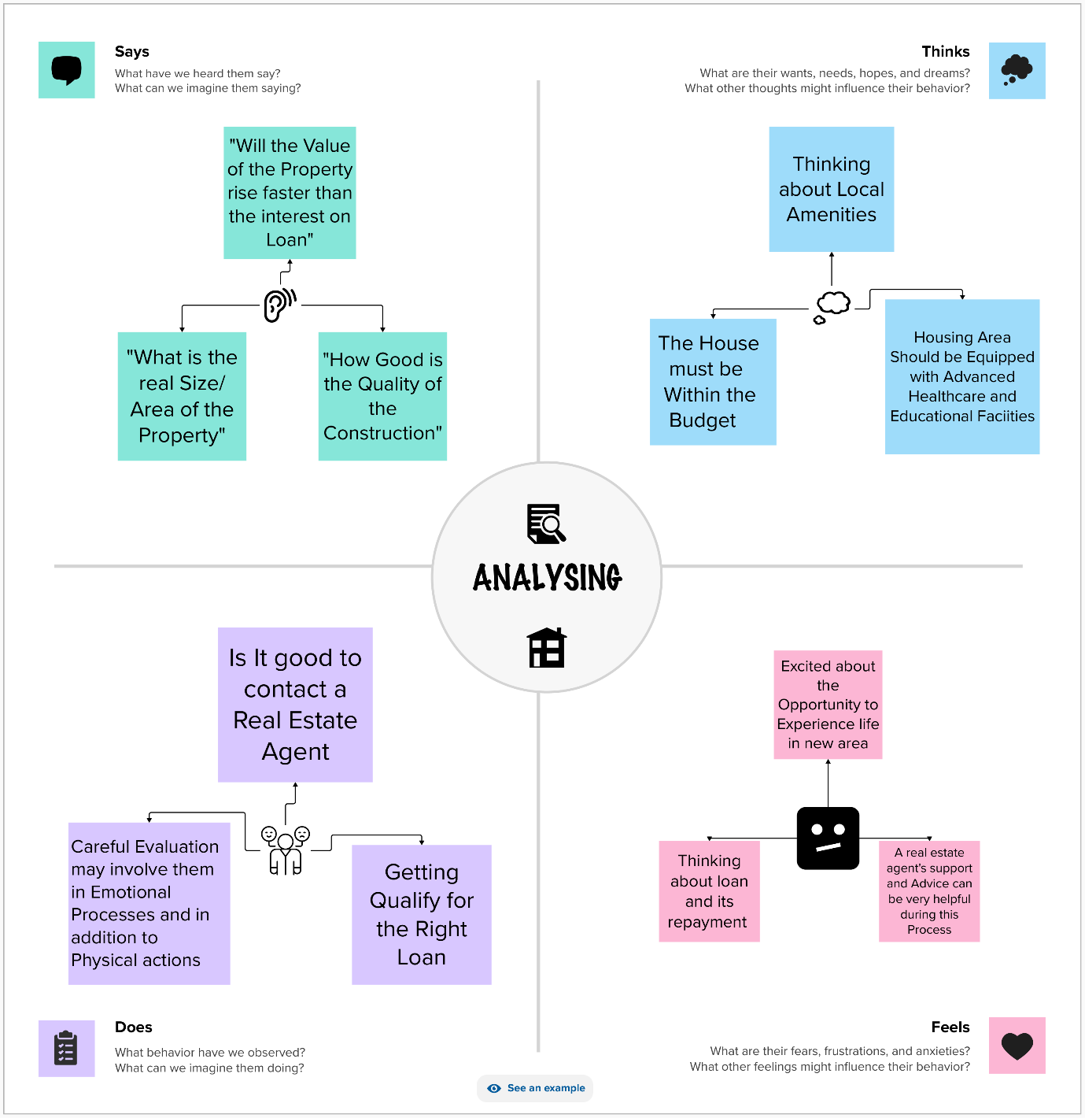

**Ideation & Brainstorming Map**

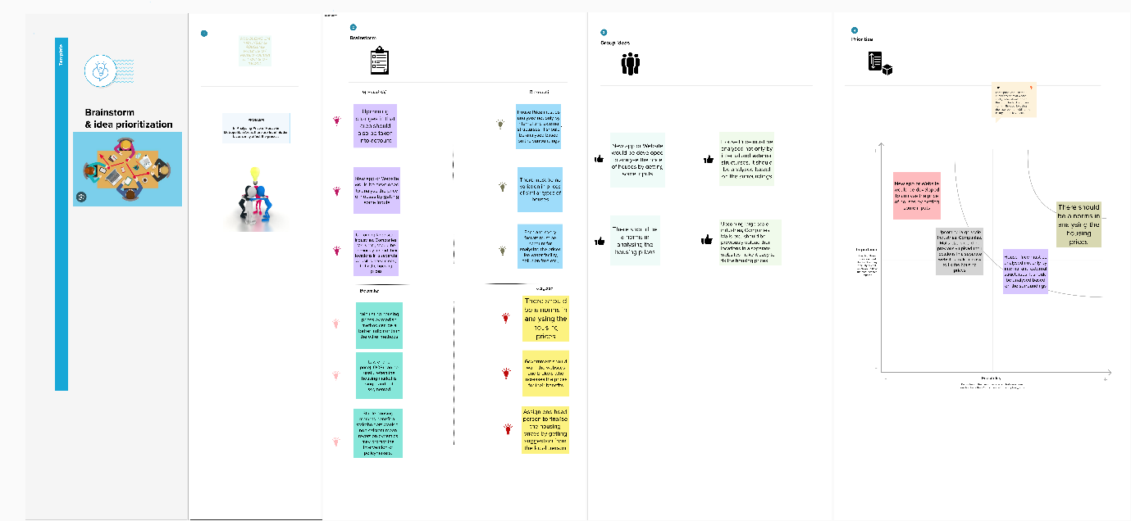

1. **RESULT**

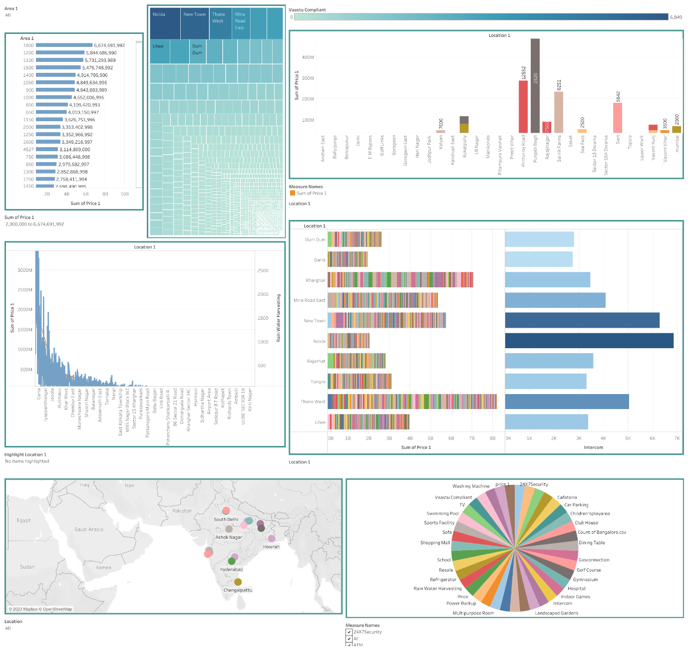

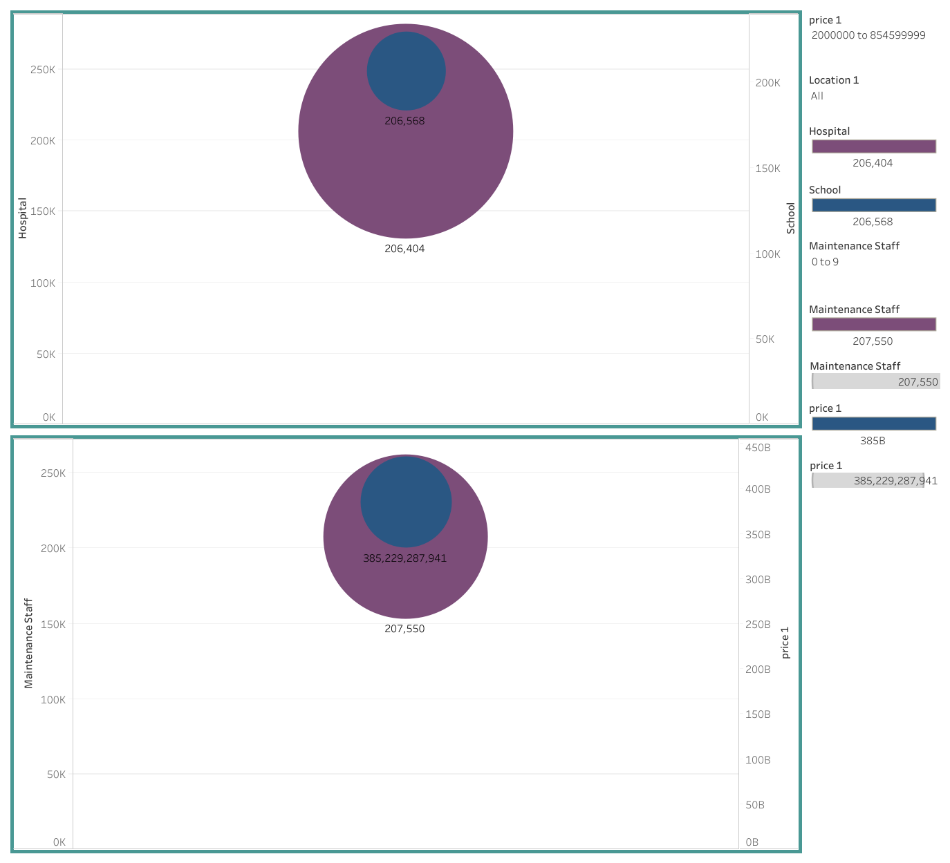

1. **ADVANTAGES AND DISADVANTAGES**

**Advantages**

Housing prediction in a metropolitan city in India is a valuable solution for potential home buyers, real estate agents, and investors. By leveraging historical sales data, property details and location-specific information, a predictive model can accurately estimate house prices. The model’s scalability, real-time updates, user-friendly interface and transparency ensure it meets the needs of stakeholders.

Integration capability, data privacy, and cost-effectiveness are also important considerations. By addressing these requirements, the prediction model provides reliable insights, empowering stakeholders to make informed decisions in the fast-paced real estate market.

* Convenience and accessibility
* Investment potential
* Appreciation in property value
* Development

**Disadvantages**

It doesn’t predict future prices of the houses mentioned by the customer. Due to this, the risk in investment in an apartment or an area increases considerably. To minimize this error, customers tend to hire an agent.

* High capital investment.
* Economic Volatility and market fluctuations.

1. **APPLICATIONS**

By using the data set one can predict the final price of houses in a region. The dataset comprises data of amenities in houses and regions. People can easily check for the facilities such as Schools, Hospitals, Malls and so many factors available in the location by using the information of internal and external factors, surroundings and so on…

1. **CONCLUSION**

Predicting housing prices are expected to help people when plan to buy a house so they can know the price range, then they can plan their finance well. In addition, house price predictions are also beneficial for property investors to knows the trend of housing prices in a certain location. This project mainly focuses on Metropolitan areas of India such as Chennai, Bangalore, Kolkata, Mumbai.

1. **FUTURE SCOPE**

House price prediction can help the developer determine the selling price of a house and can help the customer to purchase a house.

The Indian real estate market has traditionally been a significant contributor to the country’s GDP and Employment generation. The rapid urbanization, growing middle class and increased investment in infrastructure have driven the demand for real estate.

While the Indian real estate market holds significant potential, challenges such as regulatory complexities, funding constraints, market fluctuations must also be navigated. Staying informed about market trends, focusing on customer needs and adopting innovative strategies will be key to thriving in this dynamic sector.